DATA ANALYTICS WITH TABLEAU

ASSIGNMENT – 4

N.Jasmine

20NN1A0529

IV – BTECH(CSE)

VNITSW

DATASET : [Sample - Superstore.xls](https://docs.google.com/spreadsheets/d/1Vmsk3xJ_qp69U0AZzCpNybqX0AP4KSon/edit#gid%3D972120833)



Task 1:- Create one fixed and one exclude LOD expression

Task 2: Create any 2 map visualizations using geographical data.

Task 3: Create Top N and/or Dynamic dimension parameters and utilize those in your workbook.

Explain LOD Expression, Map Visualizations using geographical data and Top N, Dynamic dimension Parameters

**LOD Expression** :- **Level of Detail (LOD) expressions** are used to run complex queries involving many dimensions at the data source level instead of bringing all the data to Tableau interface.

Different types of LOD functions :-

1. Fixed
2. Include
3. Exclude

Map Visualization using geographical data :-

Tableau is a tool for analyzing geographical data. It can automatically turn location data into interactive maps.

**ZOOM Levels :- 16**

In Map Visualization, Geographical fields are double click on the field the data pane and tableau will create a map using generated latitude and longitude fields.

Top N Parameter :-

Top N parameter uses a value selected by the user, where N is a value. The value can be static or controlled by a parameter.

Top N parameter is also known as Bottom N.

Tableau allows users to filter and display a certain percentage of their data.

Dynamic Dimension Parameters :-

Create a Parameter. Create a new Parameter that lists your dimensions.

Create a Calculated field that will be used as a dimension in your worksheet. Dimension to display when a particular parameter value is selected.

Add the calculated fields to the canvas.

1. Colours
2. Filters
3. Select any ratings or price ranges.

# **Create One Fixed LOD Expression and one exclude LOD expression**

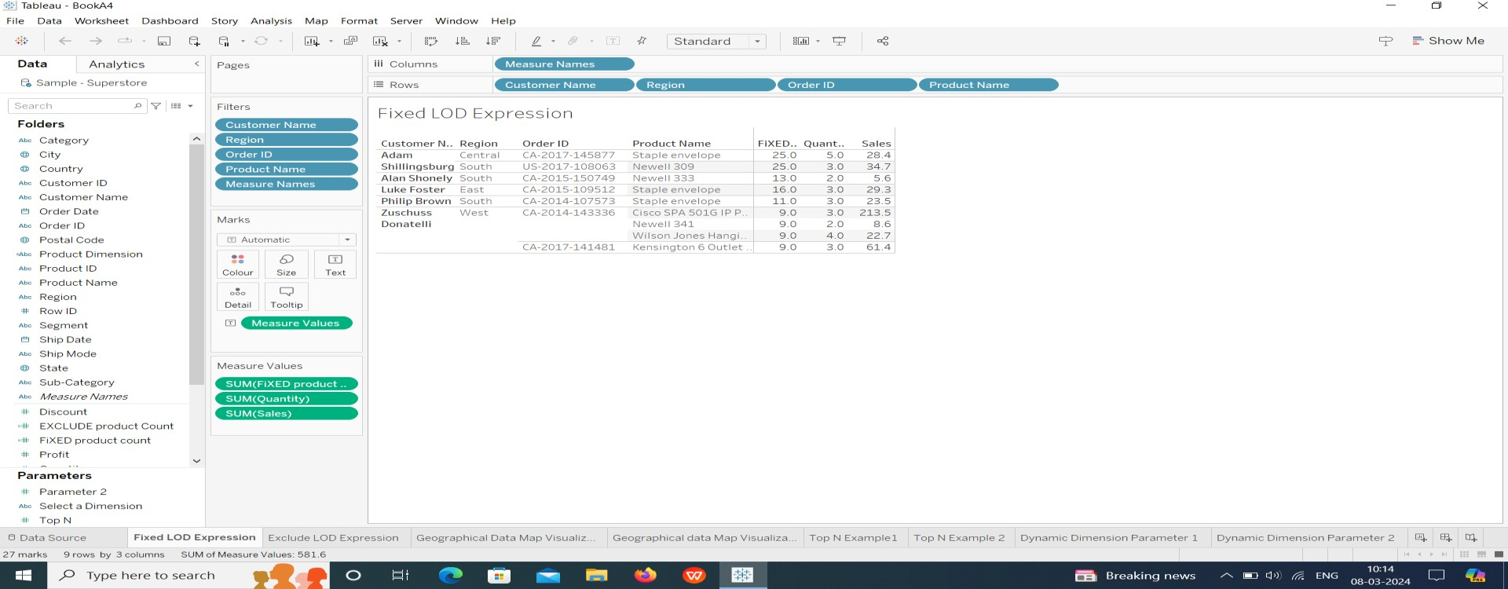1.One Fixed LOD

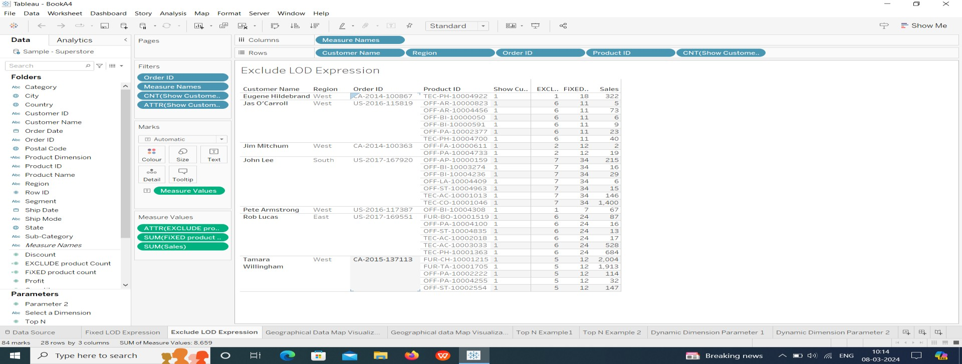2.One Exclude LOD

**Create any 2 map visualizations using geographical data :-**

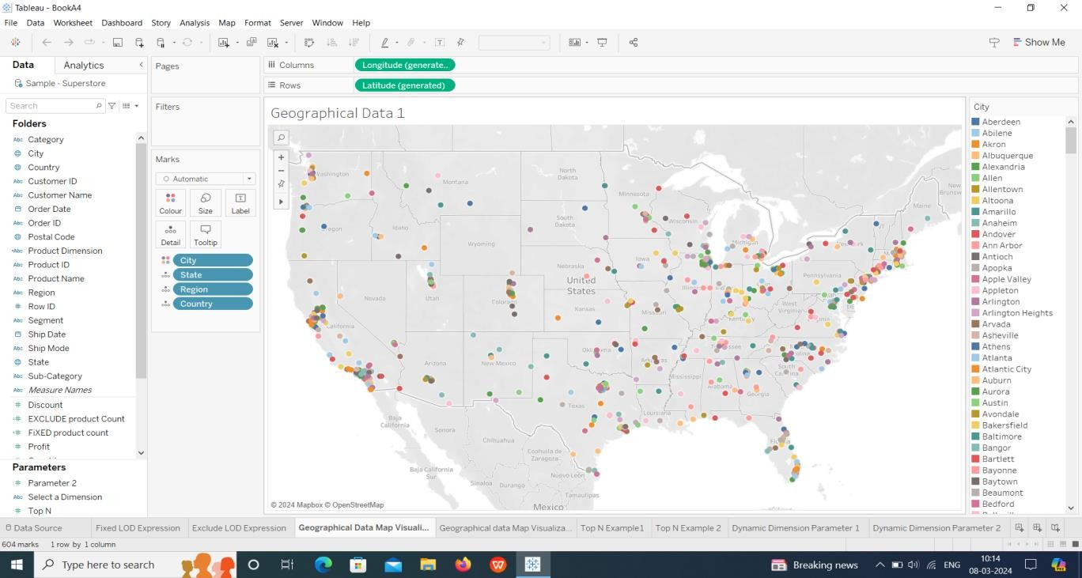Map visualization 1:

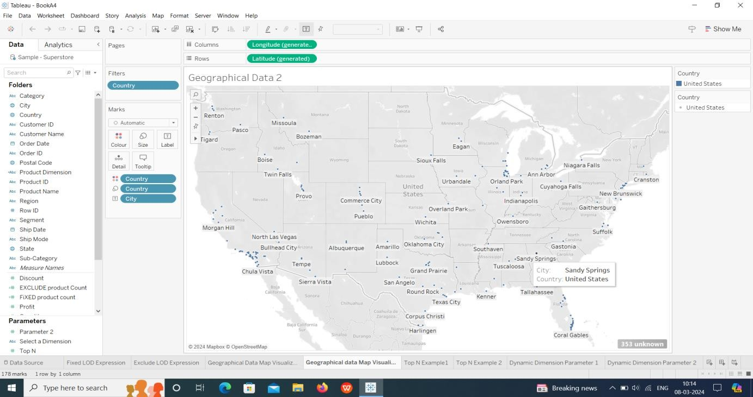Map Visualization 2:

**Create Top N and/or Dynamic dimension parameters and utilize those in your workbook:-**

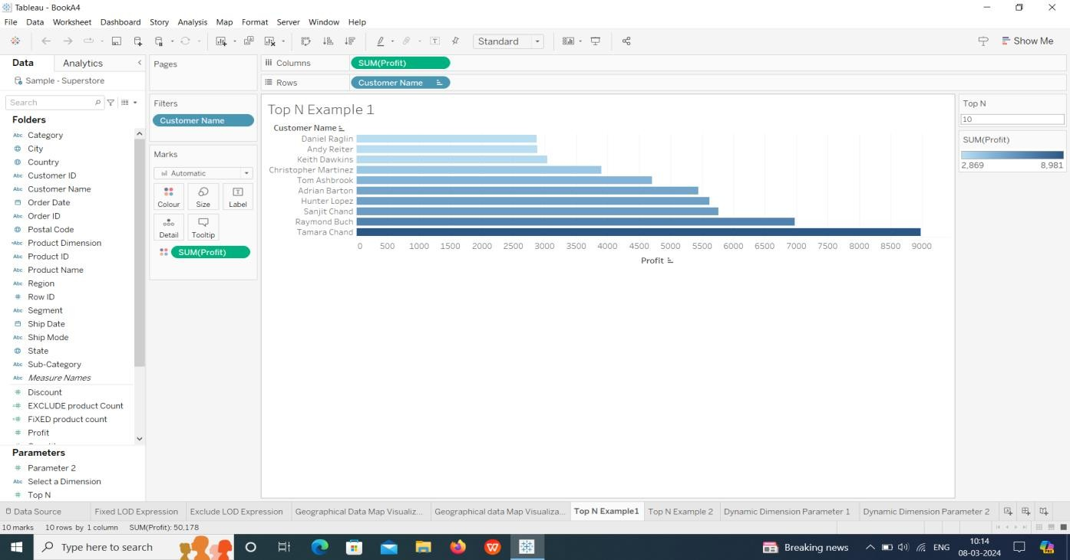Top N Parameters:

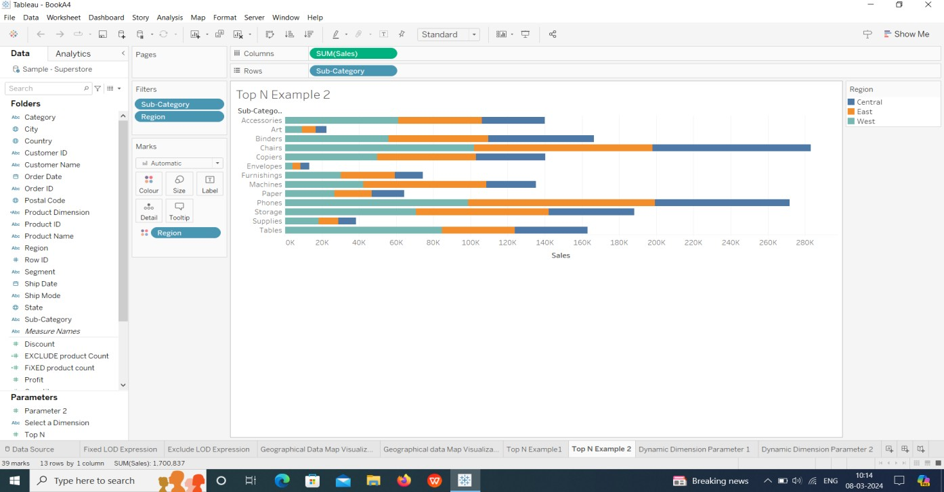

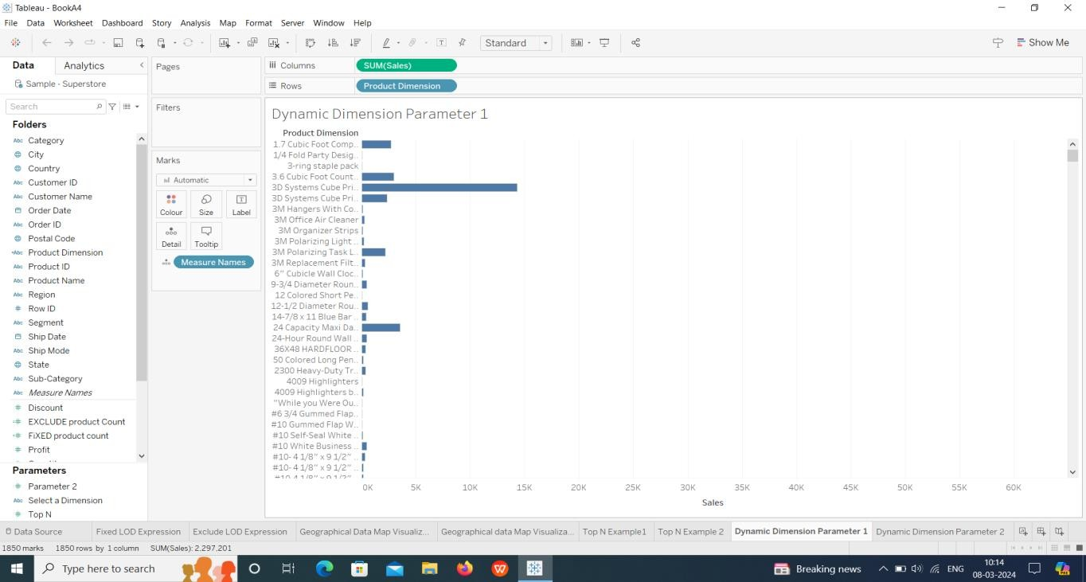Dynamic Dimension Parameter:

